# **Summer Sun and Family Fun - Something Haute's Top Picks**

We recently had the time of our lives exploring this vibrant city and let us tell you, it's an absolute blast, especially for families! So, here’s a list of Something Haute-approved places that’ll have you and your family grinning from ear to ear, whether you're craving a culinary delight, seeking an immersive experience, or simply yearning to reconnect with nature amidst the hustle and bustle of the city, Dubai truly has it all!

**Time Out Market**

Nestled in Souk Al Bahar, Time Out Market Dubai isn't just a dining spot, it's a kaleidoscope of Dubai’s culinary scene with panoramic views of the Burj Khalifa. Featuring local chefs and diverse cuisines, it's a celebration of culinary fusion. Spanning 43,000sqft, the Time Out Market Dubai line-up features several renowned homegrown eateries, including MASTI, BB Social Dining, Cafe Isan, Pickl, Pitfire, Reif, Slab Cocina, Scoopi and Long Teng. For families, it's a chance for children to experience the passion behind the dishes and glimpse into the world of food creativity.



[Time Out Market](https://www.timeoutmarket.com/)

**The Green Planet**

As we stepped into this lush oasis, we were greeted by the sights and sounds of exotic flora and fauna. With over 3,000 species of plants, animals, and birds, The Green Planet offers a captivating experience for visitors of all ages. From educational exhibits to interactive experiences like swimming with piranhas and playing zookeeper for a day, there's something for everyone to enjoy.

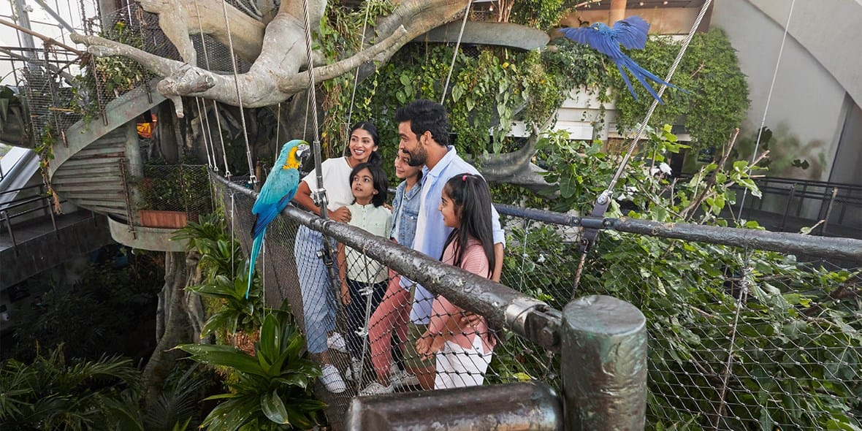

[The Green Planet](https://thegreenplanetdubai.com/)

**Sonara Camp**

As we enjoyed in the serene ambiance, indulging in a unique dining experience under the starry sky, we couldn't help but savour every moment. French chef Franck Sanna's masterful blend of regional and western flavours took our taste buds on an unforgettable journey. Later, our adventure took us into the desert for some exhilarating sandboarding and mesmerizing stargazing, leaving us in awe of nature's wonders. Amidst our own adventure, we couldn't help but imagine the joy children would find in activities like volleyball and soft archery at the Sonara Kids Camp. It's evident that this destination offers something for everyone, making it the perfect family getaway.

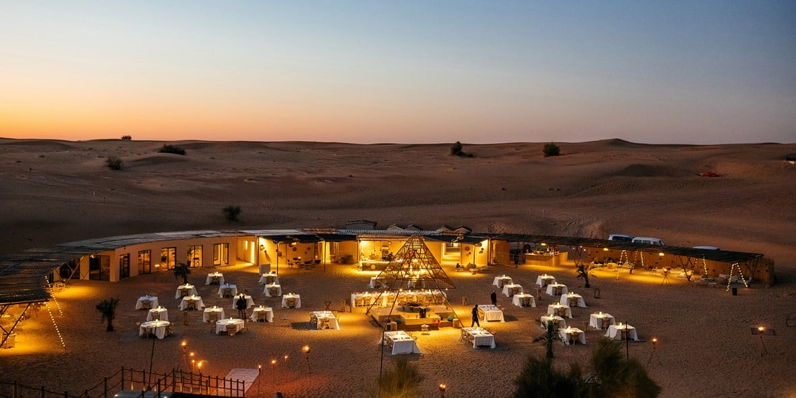

[Sonara Camp](https://www.nara.ae/sonara/)

**Dubai Autodrome**

As we explored Dubai's vibrant Motor City, we couldn't resist Dubai Autodrome, a haven for motorsport enthusiasts. Nestled within this bustling hub lies an adrenaline-packed paradise, boasting an FIA-sanctioned 5.39km Race & Drive Centre and Karting track. While we eagerly anticipated the high-speed racing adventures, we were delighted to discover that Dubai Autodrome caters to the entire family. Kids aged above 7 can ignite their passion for racing with indoor karting, while teens above 13 can take on the outdoor karting track, provided they meet the height restrictions.

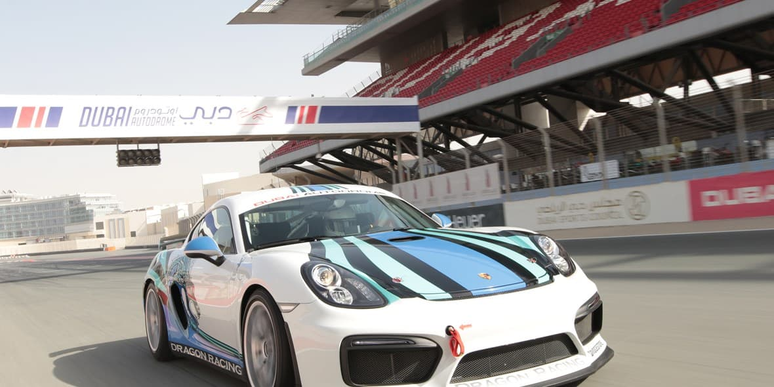

[Dubai Autodrome](https://dubaiautodrome.ae/)

**Xclusive Yachts**

We couldn't miss out on the opportunity to explore Dubai's stunning coastline and iconic landmarks from the comfort of a yacht with Xclusive Yachts. With a fleet ranging from 22ft boats to 125ft houseboats, there was a vessel to suit every group size and preference. Passing by other yachts, we couldn't help but notice the joyful laughter and excitement of children enjoying specially tailored activities. From swimming and snorkelling to playing with exhilarating water toys, it was evident that Xclusive Yachts catered to families, ensuring that kids had the time of their lives while parents relaxed and enjoyed the luxurious experience.

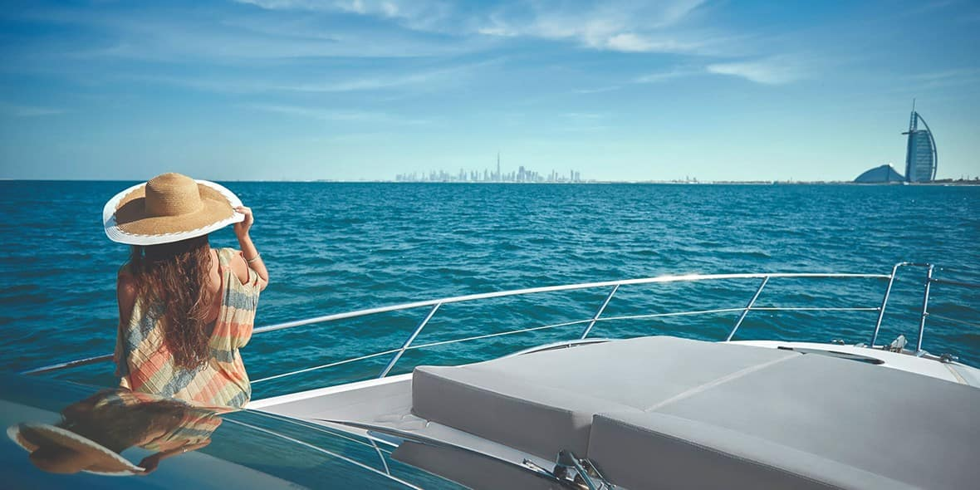

[Xclusive Yacht](https://xclusiveyachts.com/)

**AYA Universe**

Our Dubai adventure wouldn't be complete without a visit to AYA, the city's immersive entertainment destination. As we stepped into this sprawling 40,000 square foot space, we were transported into a vibrant universe filled with high-tech sound, lights, and graphics. From interactive exhibits to audio-responsive environments, AYA offers an unparalleled entertainment experience for the whole family.



[AYA Universe](https://www.aya-universe.com/)

Stay tuned as we share more about our Dubai escapades and what makes it the ultimate summer vacation destination!